**JMeter CSV Data Set Config**

JMeter, an open source load testing tool, has an element that allows you to use external data sets in a CSV format. This element is called the “CSV Data Set Config”. The CSV Data Set Config is used to read lines from a file and to split them into variables.

Steps:

* Create CSV file

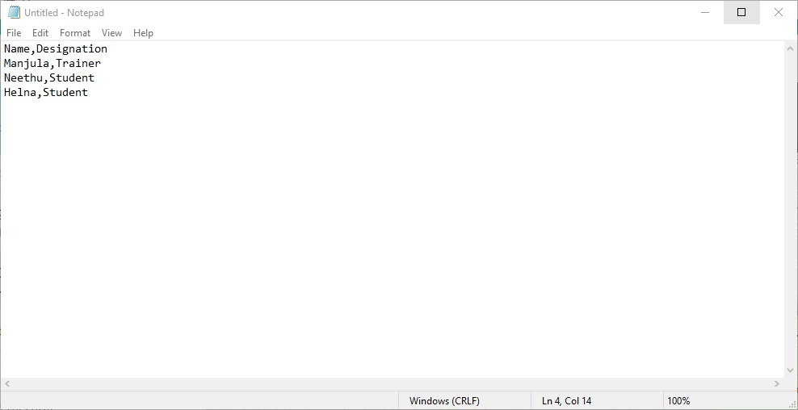

Save

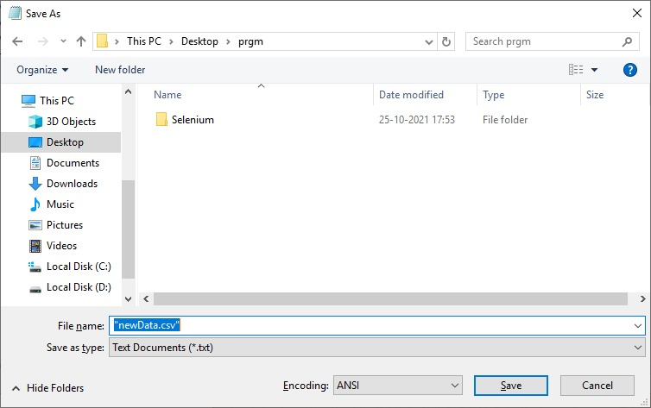

* Create a test plan. The Test Plan contains one Thread Group.
* Add Config Element to the Thread Group

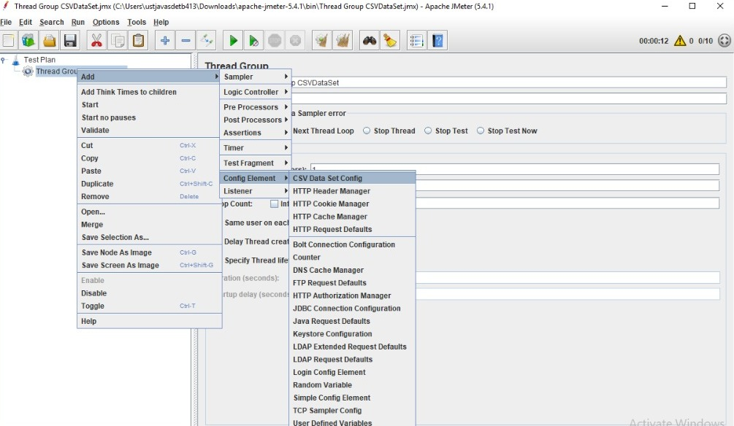

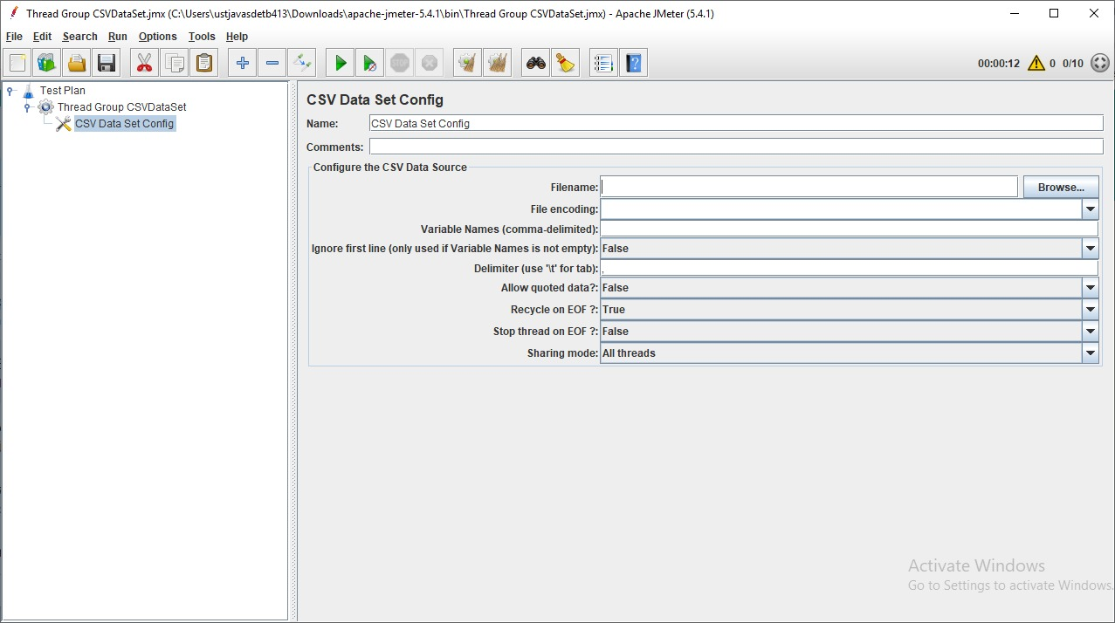

* Browse a CSV file

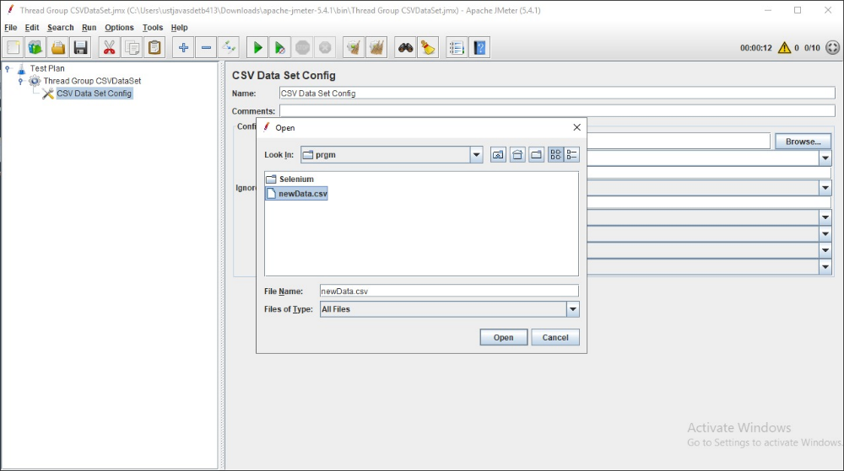

* Filename: if your file is in the /bin directory, enter just the filename. If it’s somewhere else, use the full path to the file.
* Variable names: Define your column name mapping as a list of comma-separated strings. BlazeMeter uses these names as parameter names to refer to data columns. To skip a column, add an extra comma with no name.

Examples:

* + user,passwrd,cookielength,cookieneverexp
  + lastname,firstname,,street,number,,
  + For a CSV file with six columns, this mapping lets you reference column 1,2,4,and 5 with the given parameter names, and you ignore column 3 and 6.
* Delimiter: A comma is the default delimiter, but if your file uses tabs, enter \t here.
* Ignore first line? If the first row of the csv file contains column names, enable this option. If the first row contains data, disable this option.
* Allow quoted data? If your column values can contain commas, and you also use commas as delimiters, then allow quoted values.

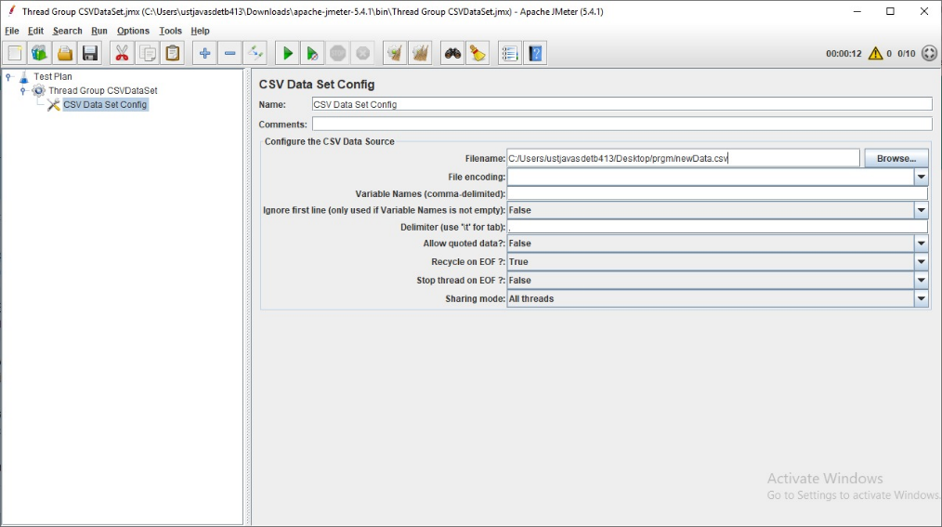

* Add a Sampler called Debug Sampler

This is used for something that allows you to read the values of JMeter variables.

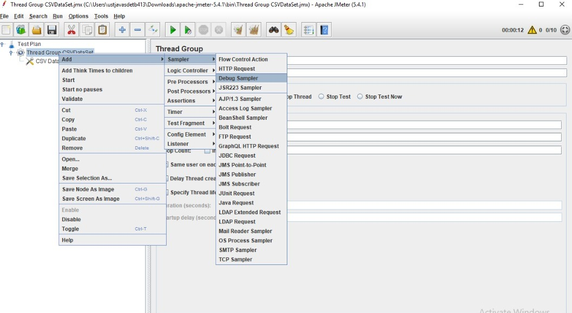

* Add Listeners

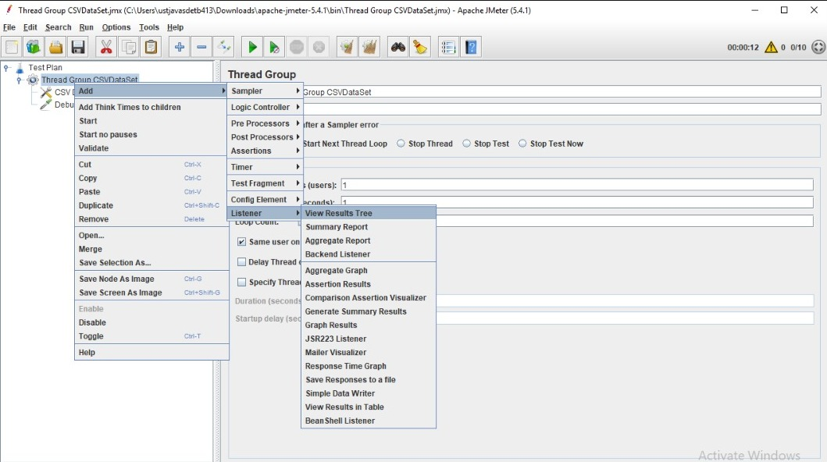

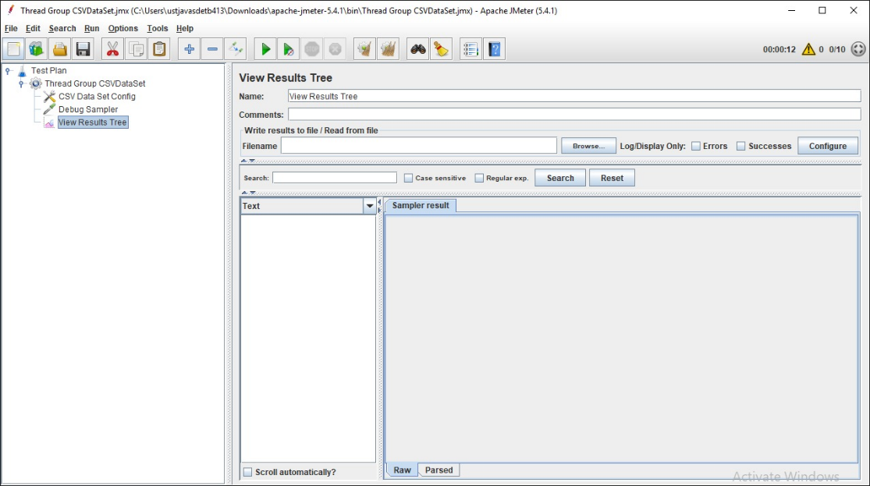

* Run the Test

Result:

The response data Shows only one value.

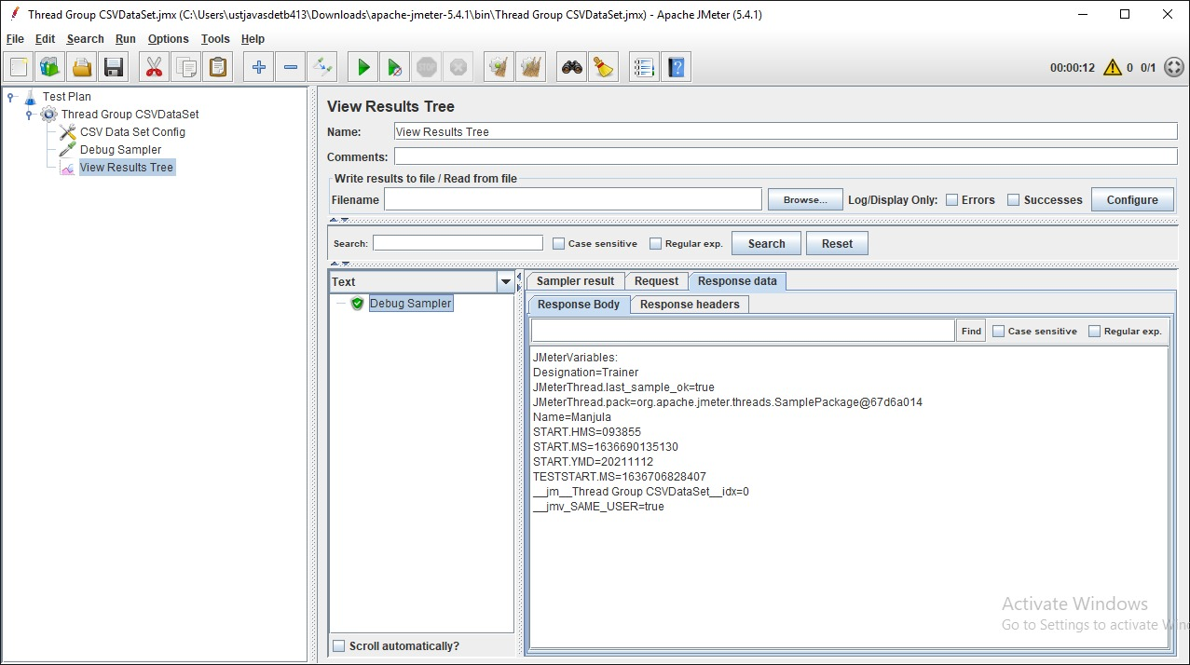

If you run it again, It reading the same data.

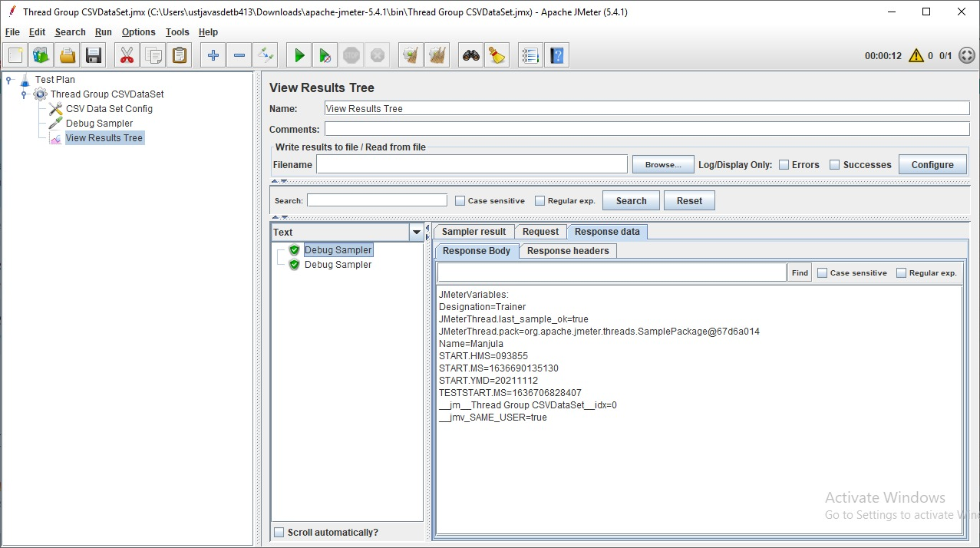

If we want to show all of the data in a csv file, the number of data in the csv file and the number of users in Thread Group must be the same.

Example: If we have 3 data in CSV file then we need to set 3uses in Thread group

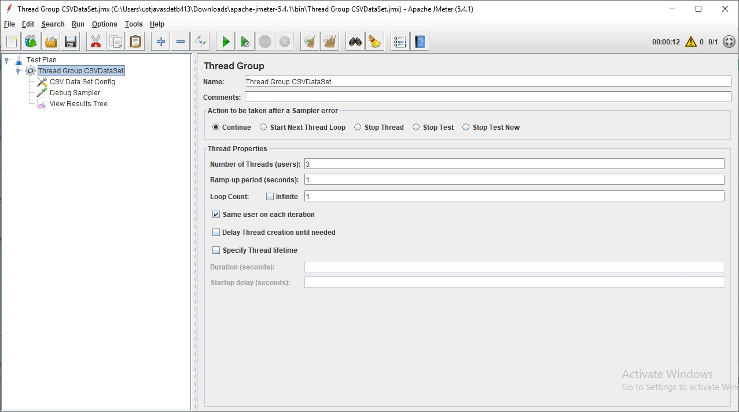

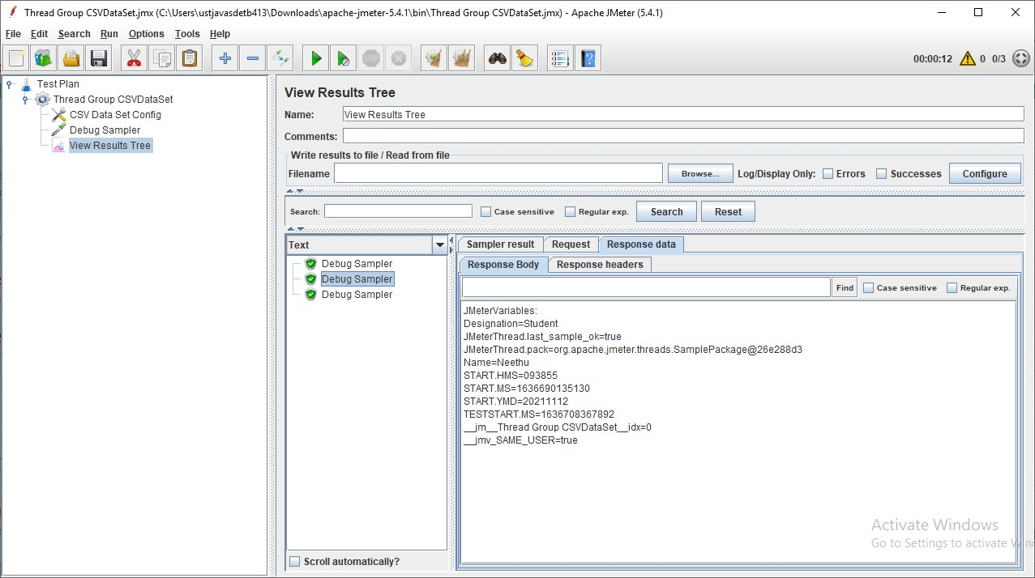

If Specifies more user and run that again, it will execute well and shows the data is started to repeat again.

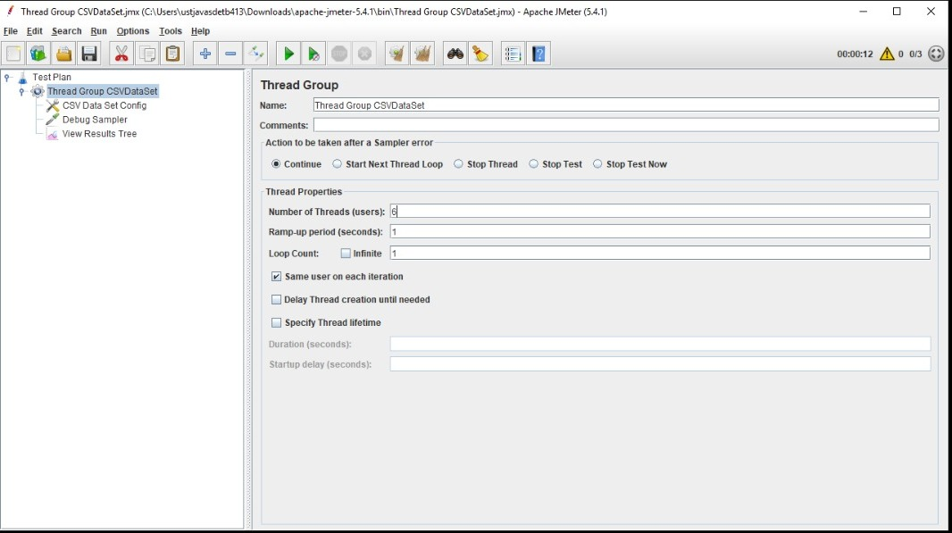

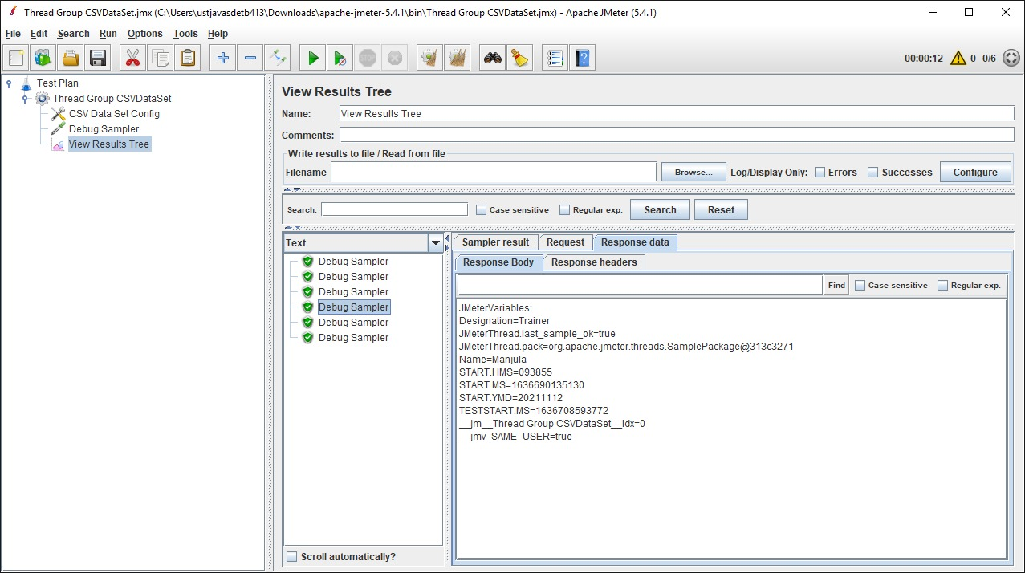

Recycle on EOF: true by default, should JMeter restart from the beginning when the End Of File is reached,

If we choose it is false, It will restart from beginning but shows the value as <EOF>.

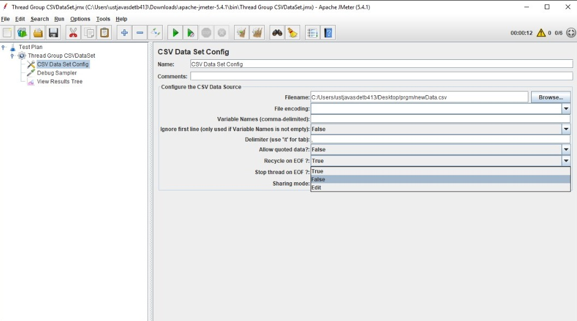

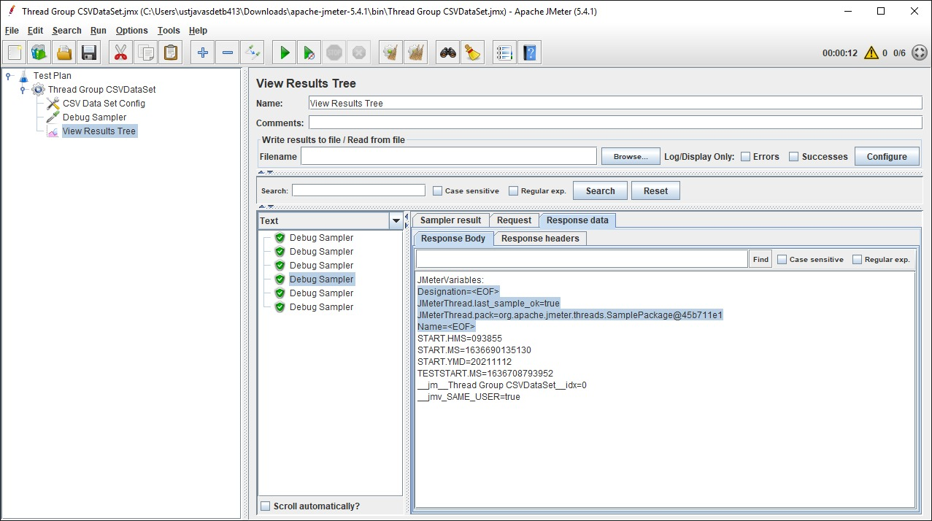

Stop Thread on EOF: stops the current thread gathering the value if EOF is reached,

It displays the same number of samplers as the number of data in the CSV file.

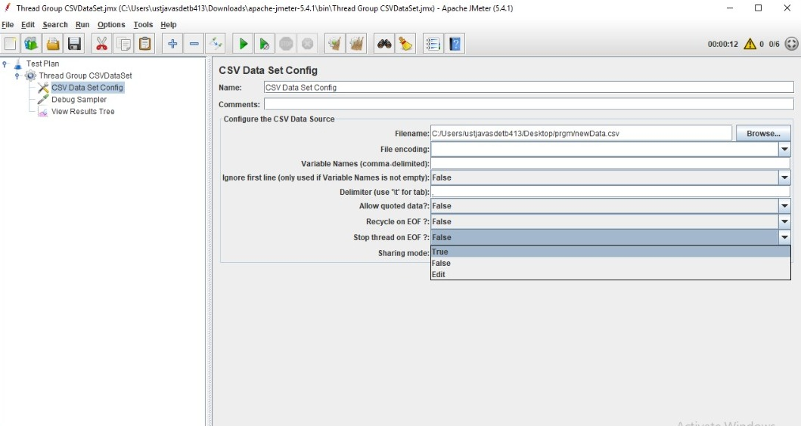

It shows 3 sampler even if we specifies 5000 users.

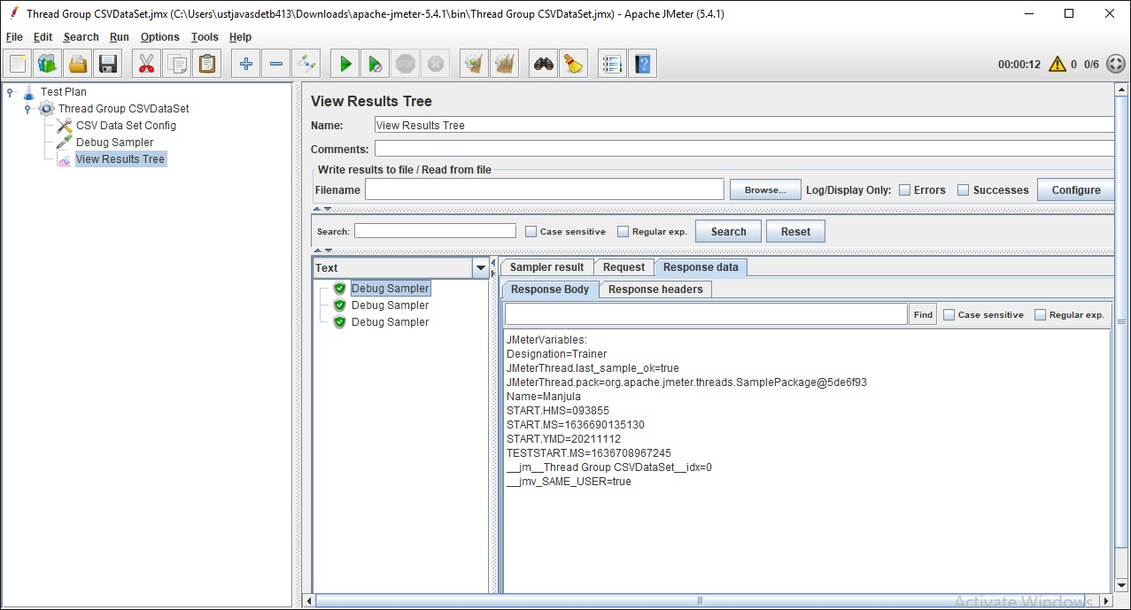

Sharing Mode: defines how values are distributed among concurrent threads.

